**Project Report**

**Subscriber’s galore: List of most subscribed YouTube channel .**

1. **Introduction**

**1.1.Overview**

YouTube is the official YouTube channel for the American video sharing platform YouTube, spotlighting videos and events on the platform. Events shown on the channel include YouTube Comedy Week and the YouTube Music Awards. Additionally, the channel uploaded annual installments of YouTube Rewind between 2010 and 2019.

**Growth and development of YouTube channels**

Views: Find which of your videos get the most views—this will tell you the kinds of content your audience prefers. Video Subscribers: Discover which videos are converting viewers into subscribers. Some videos might just be one-hit wonders, while others might be gaining you lifetime followers.

* 1. **Purpose**

**The use of this project**

* Exposure to a Worldwide Audience. …
* Marketing on YouTube Will Help You Get Found on Google. …
* Gain Qualified Traffic. …
* YouTube Ads Can Help You Reach Even More People. …
* Other Ways To Repurpose Your Videos.

**Achievements**

You’ll be rewarded a new card each time your channel hits one of the preset milestones. The goals focus on gaining a certain number of subscribers, views, or watch time hours. The more your channel grows, the more achievement cards you’ll own.

1. **Problem Definition & Design Thinking :**

**2.1 Empathy Map**

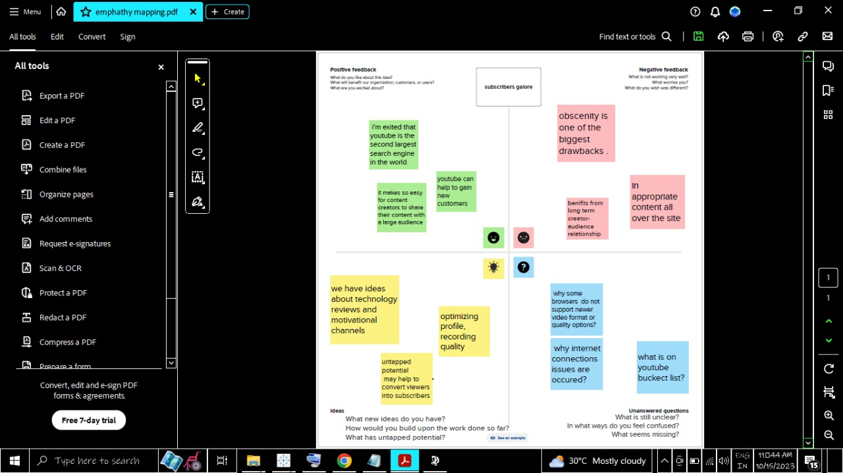

* 1. **Ideation & Brainstorming Map**

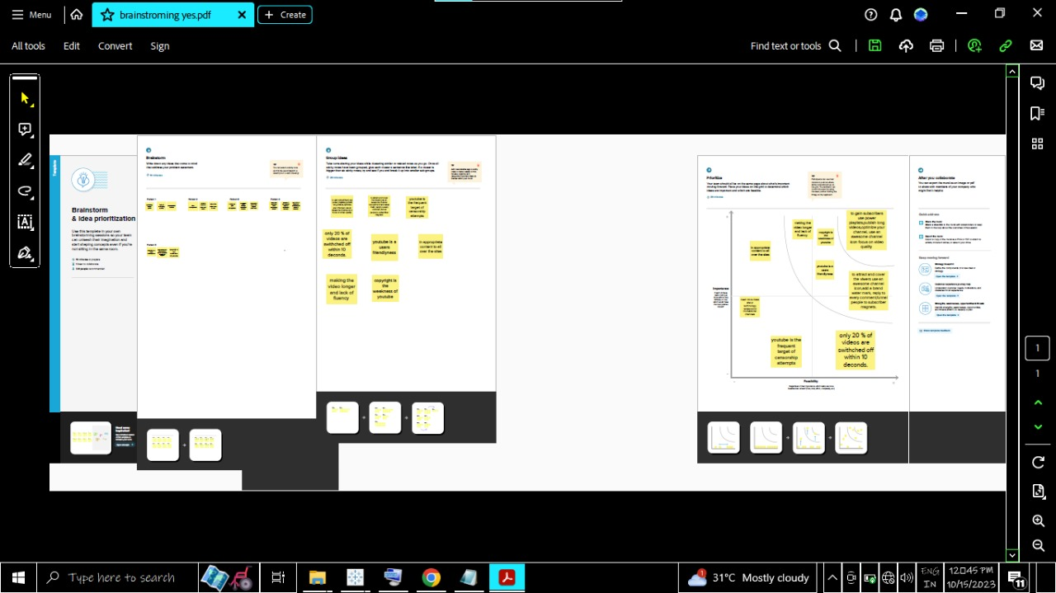

**3.Result**

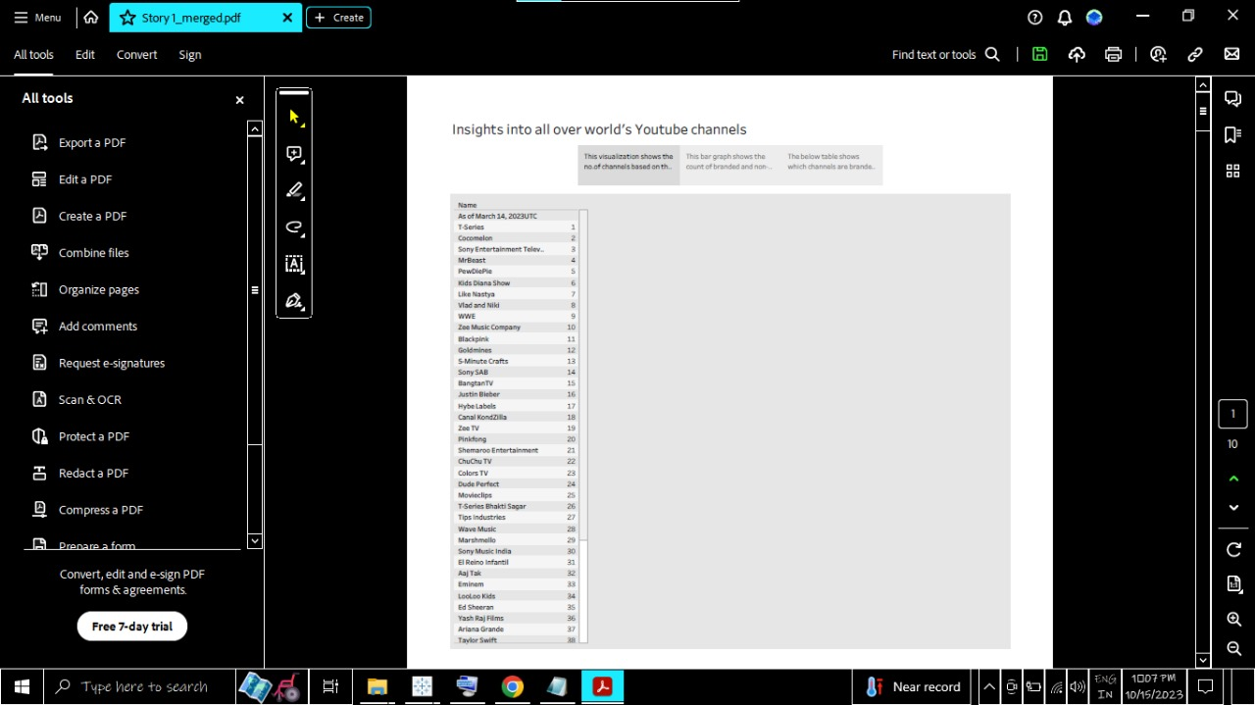

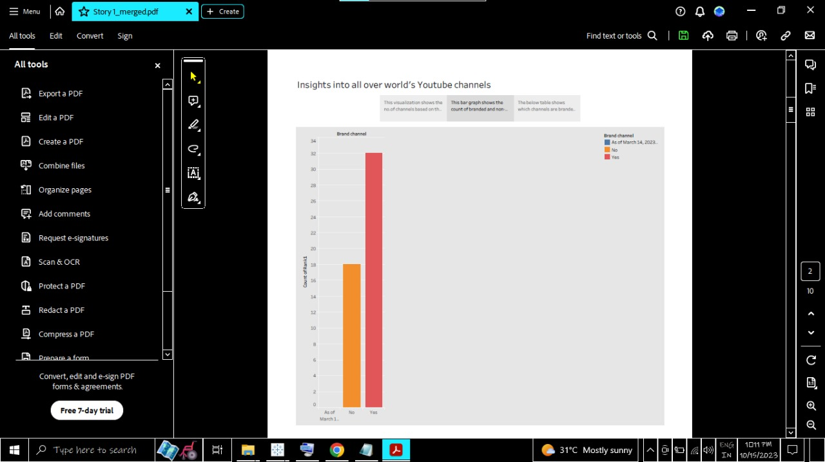

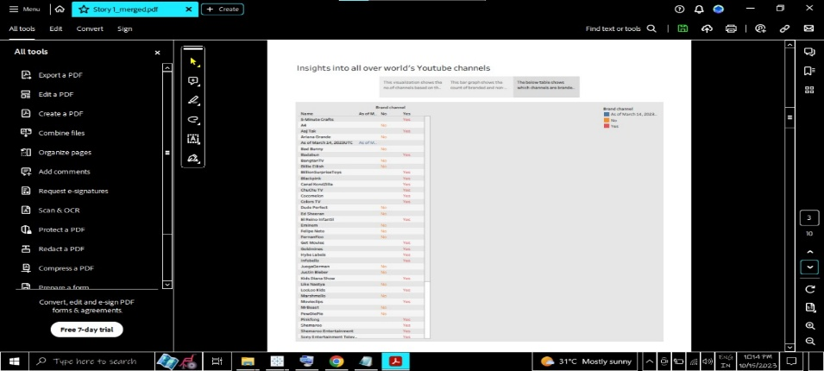

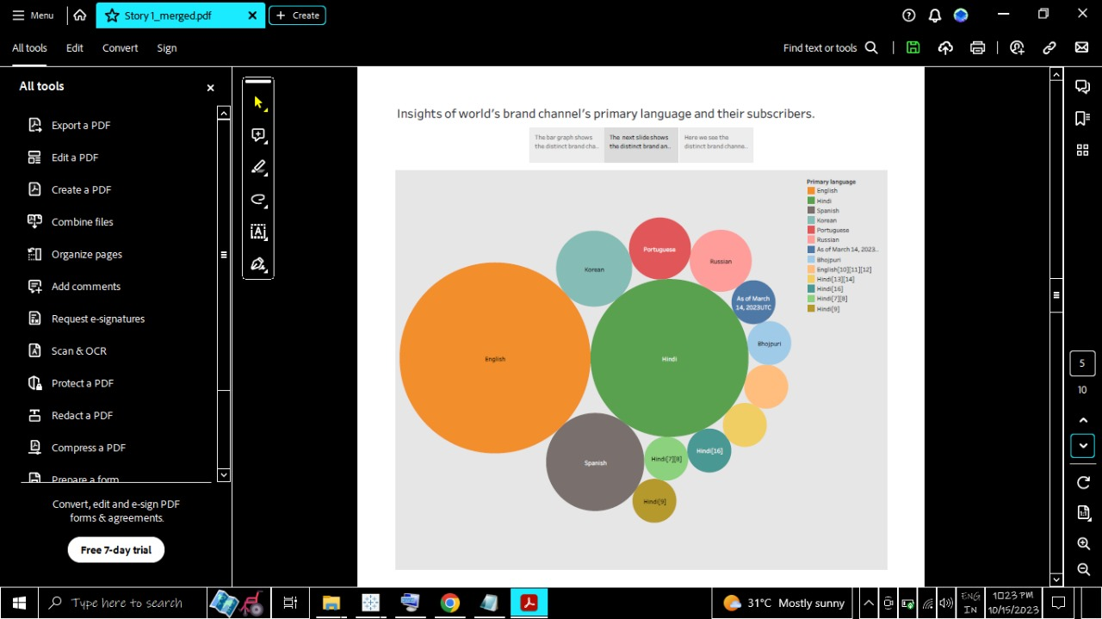

**4.Advantages**

* YouTube as an information disseminating platform for students.
* It’s the perfect place to learn and gain expertise. …
* YouTube’s user-friendliness.
* YouTube for Brand Promotion.
* YouTube benefits talented people.
* Easy Earning is at the very top of the list of YouTube benefits for Vloggers.

**Disadvantage**

* Lack of control. As much as you can control the number of times your ad is viewed, however, where your ad is played is not entirely within your control. …
* Time-Consuming Process. …
* Ads Can Be Skipped. …
* Irrelevant Audiences. …
* Bad Publicity Can Harm. …
* Cost of Maintenance.

**Application**

The combination of visuals and audio — along with YouTube’s content culture of simple, digestible messaging — makes YouTube videos a great tool for engaging students in learning. In fact, 91% of educational institutions say video increases student satisfaction.

**Conclusion**

YouTube is the 2nd largest search engine next to Google. People upload more than 100 hours of video per minute to YouTube. It’s one of the best ways to communicate to a wide audience, whether you’re promoting programs or providing information to students.

**Future scope**

Over the next decade, expect it to expand into an all-encompassing entertainment service, where you’ll not just watch and listen: you’ll play. Games, and interactive experiences. In both cases partly driven by YouTube’s evolution into the world’s largest catalogue of virtual reality content.